ASSIGNMENT 06
TCP Congestion Control – Complete Lab Task
Q1. LAB TASK: TCP Congestion Control Simulation
Question:
Using a TCP congestion control simulator (Python or any tool of your choice), simulate and analyze TCP Reno under three different packet-loss conditions:
- 0.1% loss
- 1% loss
- 2% loss
For each case:
- Plot the Congestion Window (cwnd) vs Time for at least 20 seconds of simulation.
- Compute the average throughput (in MSS/second or Mbps).
- Explain how packet loss affects the behavior of TCP Reno, specifically discussing:
  - Slow Start
  - Congestion Avoidance
  - Multiplicative Decrease (cwnd halving)
CODE: 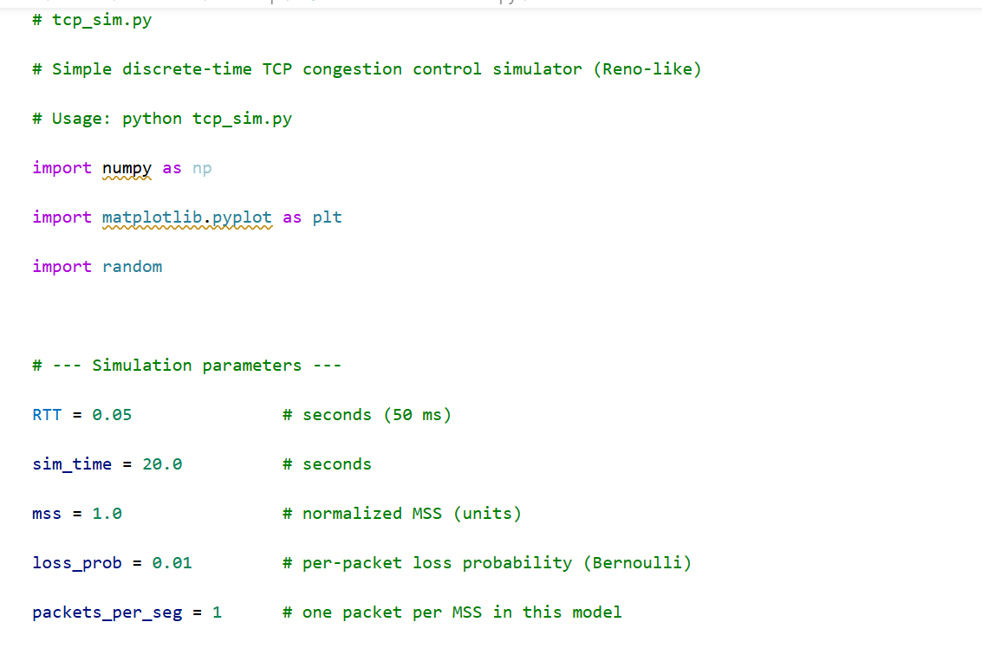

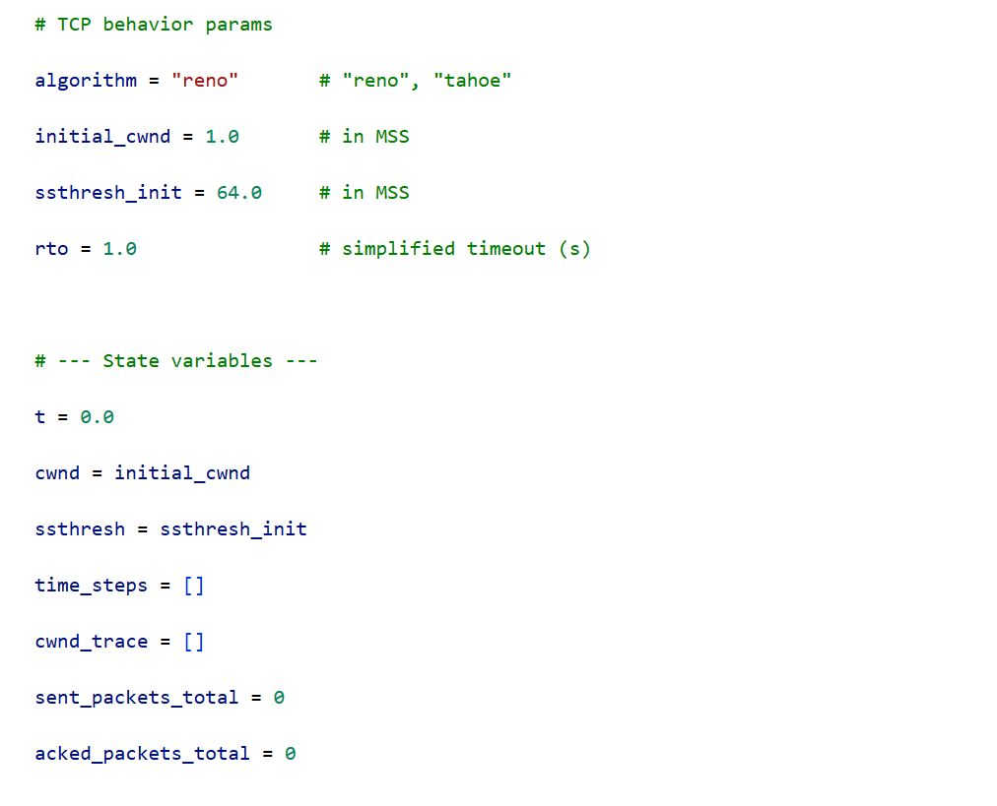
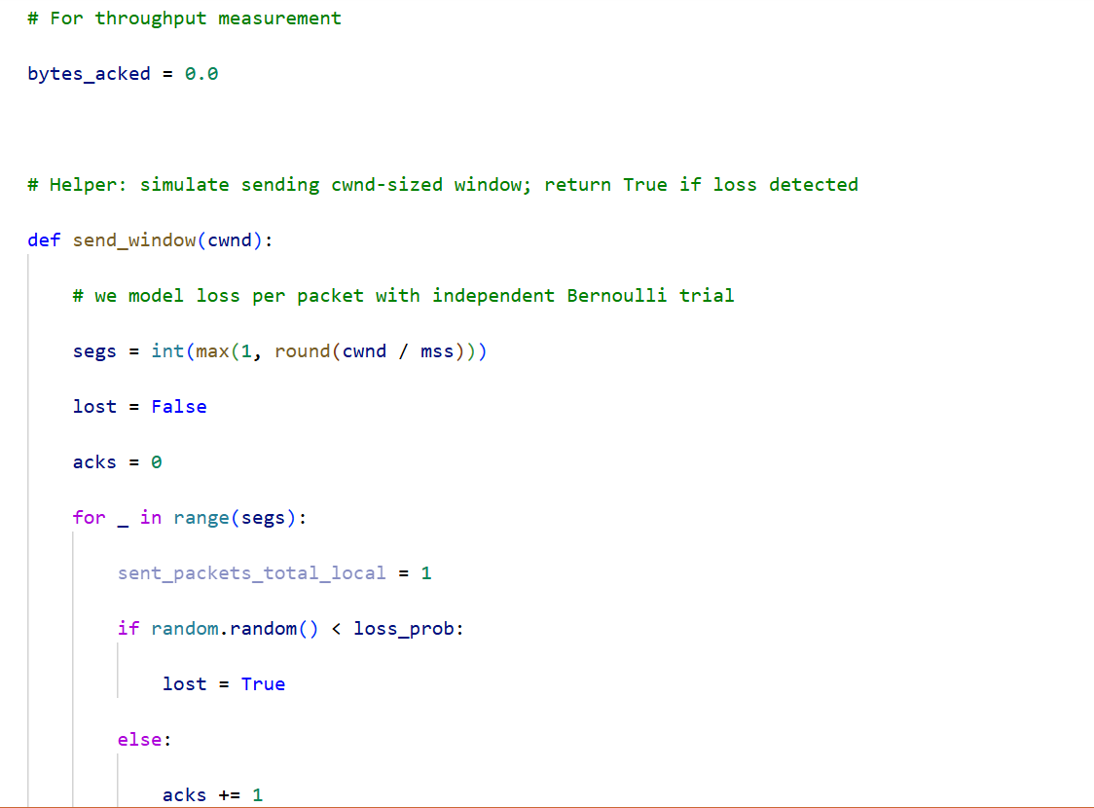
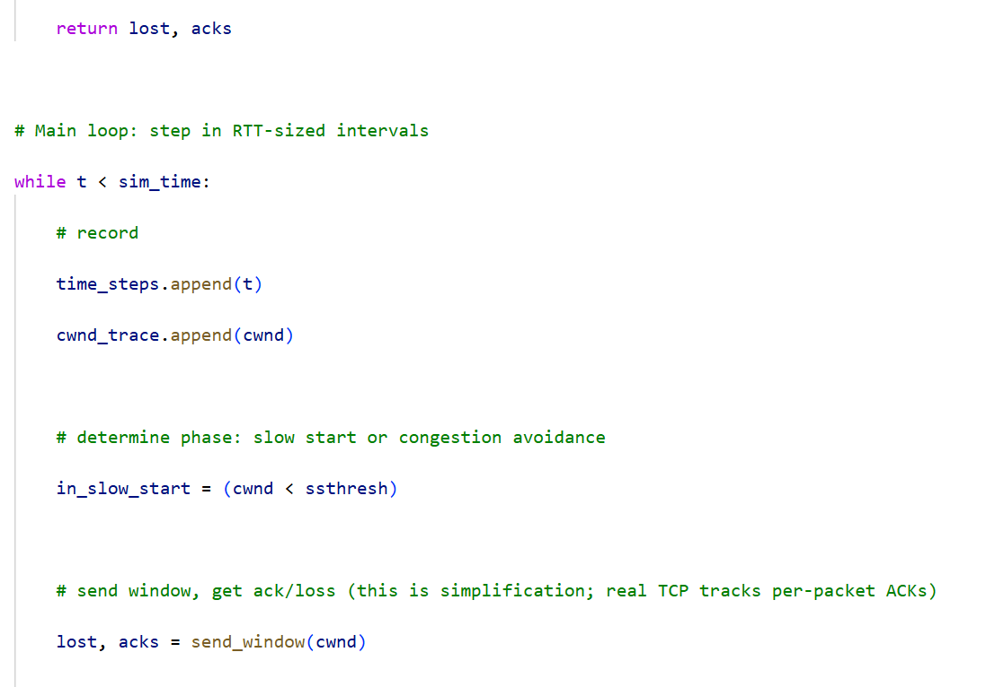
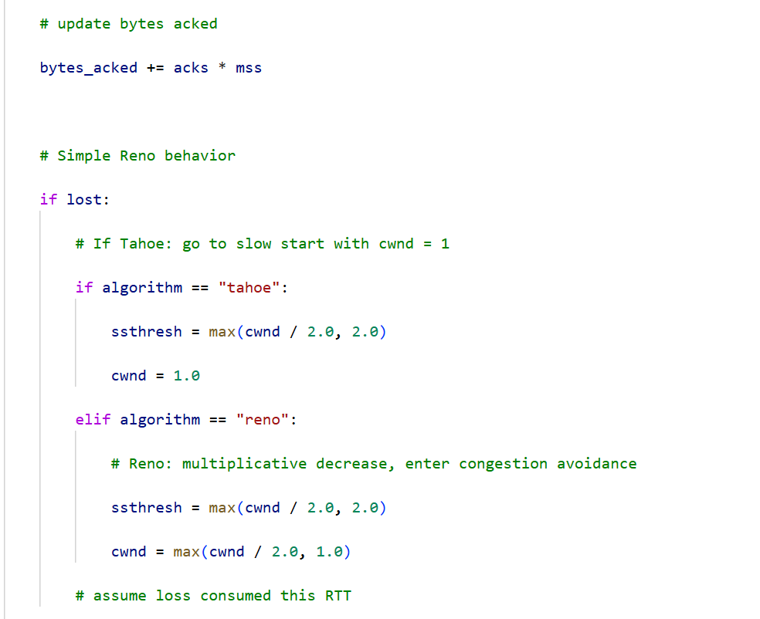

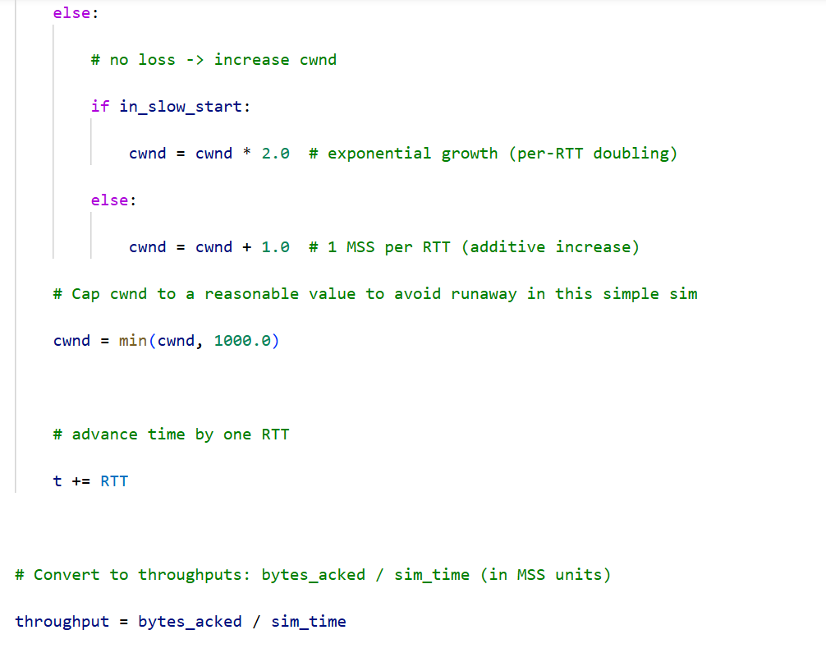
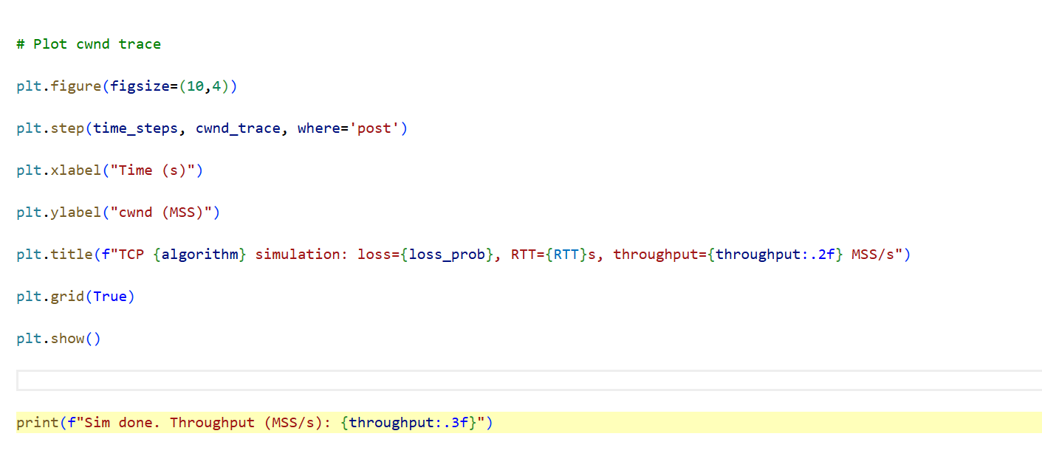

OUTPUT:
